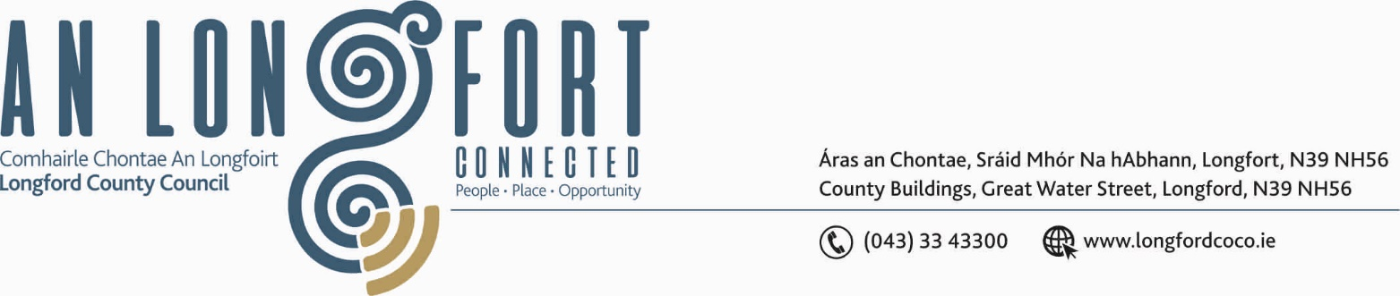

BALLYMAHON MUNICIPAL DISTRICT

12th June 2020

To: Each Member of Ballymahon Municipal District.

A Chomhairleoir,

You are requested to attend the Annual Meeting of Ballymahon Municipal District to be held in Sports Hall, Leisure Centre, Albert Reynolds Peace Park, Longford on Thursday, 18th June 2020 at 4.00 p.m.to transact business, as set out on the Agenda hereunder.

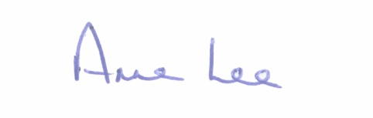
Mise le meas,

_______________
Anne Lee,
Meetings Administrator.

C L A R

1. Election of Cathaoirleach.

2. Election of Leas Cathaoirleach .

3. Fix date and time of Ballymahon Municipal District meetings.



